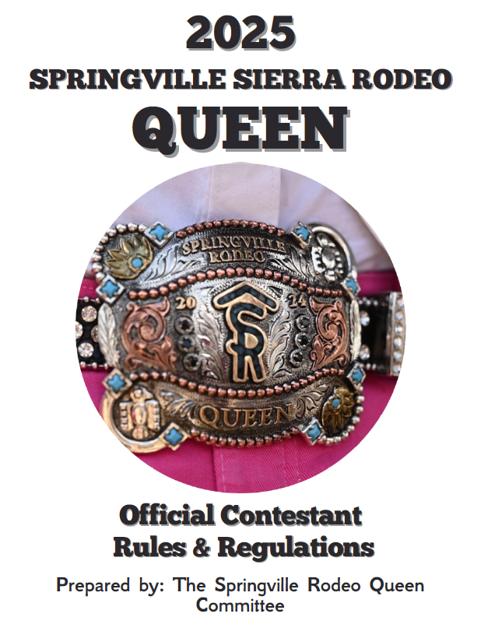

Springville Rodeo Queen Pageant

The Springville Rodeo Queen Pageant is held annually to select a young lady who has the desire and enthusiasm to serve as a goodwill ambassador for the sport of professional rodeo and the community of Springville.

The board of directors is confident that the contestant chosen as Springville Rodeo Queen will represent her rodeo and the community of Springville in a grand manner, while promoting the sport of professional rodeo.

Who is Miss Rodeo Springville?

- A young lady who wishes to be a representative of the community of Springville and professional rodeo

- A young lady who loves horses, rodeo, and everything they represent

- A young lady who portrays unmatched sportsmanship, high moral and ethical character

- A young lady who understands and loves the sport of professional rodeo

- An ambitious young lady who is interested in furthering her chosen career through higher education and special training

- A young lady who can speak intelligently and display dignity in all situations

- A young lady who will be an ambassador of Springville for the sport of rodeo

Eligibility

- Queen contestants must not be less than 15 years of age or more than 20 years of age as of coronation day April 25th, 2025.

- Contestants have never been married

- Contestants may not have children

- Contestant chosen as Queen agrees to remain unmarried throughout her reign, as well as not have any children.

- Attendance is MANDATORY at all calendar events. Contestants who find it necessary to miss a calendar event MAY FORFEIT their 25% ticket sales reimbursement.

- All contestants shall agree in writing to observe and comply with all these rules and regulations, as they exist now and as subsequently amended.

- Applications, Waivers & Expectation agreement must be postmarked or hand delivered by February 18th. If at this time there are three or less contestants then the Rodeo Queen committee reserves the right to extend the deadline.

Promotional Activities

- Contestants shall attend all performances of the Rodeo unless specifically excused there from by the Rodeo Queen Committee.

- At all such functions, performances and events, each contestant shall be dressed in western attire all of which shall be furnished at the sole cost and expense of the contestant.

- At any event requiring the contestants to be mounted, each contestant shall provide the horse to be used by her, together with all the necessary tack at her sole cost and expense. The contestants must also provide all transportation for herself and her horse to and from the site of the function.

- Each contestant shall provide her own transportation to each such function, performance and or event.

- Rodeo Queen Committee shall have the sole right to publish or cause publication in any media, and use in any reasonable manner, the name, basic biographical background and photograph of each contestant for the purpose of the promotion of the Rodeo Queen Contest.

Springville Rodeo Queen Judging Criteria

- Judges will turn in judging sheets signed and sealed individually.
- Results of contest will be tabulated by Private Accountant Firm
- Tabulation of judges scores by auditors will result in highest scoring receiving 1st place, 2nd highest score 2nd place and 3rd highest score 3rd place. Each place will be awarded the following points
1ST place 3 points
2nd place 2 points
3rd place 1 point

The following 3 Categories are of equal value and will have 3 placements
Poise and Personality
Horsemanship
Ticket Sales

In the event of placement points resulting in a tie between 1st and 2nd place in the Queen or Princess Contest, the contestant with the highest Horsemanship Placement will be declared the winner by the accountant firm..

The Judge’s Decisions are Final!

4. The judges put score sheets in a sealed signed envelope when each event is completed. The sealed envelopes are delivered to an independent auditor.

5. Each contestant may review her personal scores following the completion of Sunday’s performance.

6. No contestant or person on the contestant’s behalf shall be in contact with accounting firm personnel.
Rules and Regulations

1. Contestants must conduct themselves in a proper lady-like manner and portray high moral standards. Contestants will not be permitted to drink alcoholic beverages, smoke, or use foul language at any time during pageant functions or anytime while representing the Springville Rodeo.

2. A contestant or any individual with the intent to influence or harass may not approach a judge or the auditor before or after any event. Action of this type will be reported to the Springville Rodeo Queen Committee and disqualification of that contestant could result.

3. Each contestant will provide horses and tack necessary for horsemanship
competition as well as parade and grand entry.
No Stallions will be permitted.

4. Contestants must provide their own transportation to and from all rodeo functions.

5. Contestants must provide appropriate western apparel with good taste for all phases of competition.

6. No chaps are to be worn for the horsemanship competition.

7. If for any reason it is determined the reining Springville Rodeo Queen cannot fulfill her duties during any portion of her term the 1st runner up will be eligible to assume the title. Upon such time as the reigning Springville Rodeo Queen is dismissed, or forfeits her title, all scholarship funds, awards and gifts given in relationship to the position must be returned to the Springville Rodeo Queen Pageant Board.

Upon entering the Springville Rodeo Queen pageant, contestants must sign a Waiver of Liability and Expectation Forms and complete an Application.

SPORTSMANSHIP -The Springville Rodeo Queen Pageant Board expects each contestant, parents, friends, and relatives to display the highest degree of sportsmanship during the pageant and following the coronation. Each contestant should be mindful that they are representing the Springville Rodeo Queen Contest, the Springville Rodeo, the community of Springville, and the Sport of Professional Rodeo. Unsportsmanlike conduct will not be tolerated. Unsportsmanlike conduct could result in disqualification and affect further eligibility to compete in the Springville Rodeo Queen Contest.

EACH CONTESTANT MUST SIGN AGREEMENT TO THE ABOVE STATEMENT IN ORDER TO QUALIFY TO COMPETE.

PAGEANT DIVISIONS

Poise and Personality

The purpose of this category is to select the young lady who rates highest in:

1. Appearance

2. Grooming, this should include neatness, cleanliness, fingernails, hair, hat, boots, and other western apparel.

3. Posture: How the contestant carries herself is very important, the judges will be looking for contestants to carry themselves straight, tall and exude self-confidence and poise.

4. Poise and ladylike behavior in every situation. Judges will be looking for
contestants to handle each situation that they are involved in with grace and style. Judges will also be looking for contestants to have a vast knowledge of proper etiquette.

5. Western fashion sense: contestants should pick outfits that reflect fashionable and tasteful western clothing. Judges will pay particular attention to the contestant’s ability to use colors to enhance her natural coloring and enhance appearance and eye appeal.

6. Proper fit of clothing: above all contestants should pay attention to the fit of their outfit. Outfits should be figure flattering and altered to fit her personality. In addition, contestants should be properly fitted for a hat so that it will flatter the face.

7. This is not a fashion contest, and we do not want contestants to spend a fortune on your clothing; we just want to see you at your best in all occasions.

8. Intelligence and good common sense.

9. Conversational ability in varied areas with an emphasis on grammar and
enunciation.

10. Good sense of humor

11. Self-confidence, high moral standards, sincerity, and integrity

12. Genuine interest in other people and consideration of others

13. Self-Projection

14. Maturity

15. Educational background and career goals

Horsemanship

The purpose of this category is to select the young lady who rates the highest in:

1. Horsemanship: Control of mount and the way each situation that may
occur is handled

2. Balance- ability to sit correctly in the saddle

3. Position of hands, feet, and seat

4. Mounting and dismounting

5. Presentation of Queens Salute

6. The understanding and skill of the contestant will be judged and not the horse or equipment

7. Showmanship

Note: The contestants will provide their own horse for the horsemanship portion. Contestants should remember that this will be judged on how the contestant queues the horse, not the horses’ ability. Contestants should strive for a smooth pattern.

Rodeo Knowledge
1. The purpose of this division is to discover each contestant’s ability to understand and comprehend the sport of rodeo and its events.

2. Each contestant will be interviewed on each of the following categories.
Knowledge of tack, horse science, professional rodeo history, rodeo terminology, explanation of standard events, championship standings, current issues of the pro rodeo circuit.

GENERAL INFORMATION
PARENTS, FRIENDS, & RELATIVES -The Springville Rodeo Queen Contest welcomes and encourages the presence of parents, friends, and relatives during the competition. The Springville Rodeo Queen Contest also requests complete cooperation from parents, friends, and relatives during pageant activities.

Ticket Sales
Tickets will be handed out to the Contestant after their application, Waiver of Liability and Expectations agreement has been signed and turned into the contest directors. Extra tickets will be given to contestants as needed throughout the competition. (Please see Ticket Audit page)
Note: All Cash awards are contingent on participation in all mandatory events.

- Raffle tickets sell for $1.00 each
- Each Queen contestant will be required to sell 1,000 tickets
- There is no limit on how many tickets you can sell
- Contestants who sell over the 1,000 required tickets will receive a 25% payback of tickets sold over the initial 1,000

Note: Remember the more tickets you sell, the more money you will get back!!

Ticket Audit

Date: TBD
Time: TBD
Location: Springville Rodeo Grounds Rodeo Office

Please note the following:

- All ticket stubs, money and unsold tickets are to be turned in at the time of the Audit.

- All tickets should be ready prior to the Audit

- Bundle your ticket stubs in books ten (10) secured by a rubber band. Please do not remove staples.

(Books do not need to be in numerical order)

- Check your stubs to be certain that all stubs are filled out.

NOTE: Ticket stubs turned in unbundled, or not filled out
WILL NOT RECEIVE SELLING CREDIT FOR THESE TICKETS. Please be prepared and have all tickets filled out properly

LIABILITY FOR TICKETS: Tickets and/or money will be returned to the Contest directors in the same amount equal to the tickets checked out. Contestants are responsible for covering any shortage of tickets or money.

Checks may be made payable to the “Springville Rodeo Association”

Horsemanship
The horsemanship competition will be held at the Springville rodeo grounds following the completion of the Poise & Personality Brunch on April 9th.

- No studs are permitted to be used in the competition or any of the horsemanship clinics.
- Contestants are to provide their horses for the entire contest.
- DON’T FORGET TO SMILE!!

1) On the day of the competition contestants will draw for positions. Upon
completion of drawing parents, trainers and anyone else associated with
the contestants will be asked to take a seat in the stands until the
judging is completed. Each contestant will be allowed to have one
person remain with them during the competition.

2) Contestants are to wear western or western show attire, hat and boots
for horsemanship portion of the contest. No contestant is permitted to
wear chaps of any kind.

3) Each contestant will be judged on her ability to control her horse and the
response her horse has to her commands. Horse and rider should be
good working partners.

4) Once the last contestant is finished, all contestants will enter the arena
and line up in numerical order in the center of the arena so the judges can make their final scores.

Note: Although it is not your horse or tack being judged you should still take pride in your attire and the cleanliness of your horse and tack.

The horsemanship portion of the competition will consist of rail work, one pattern, and a Queen’s salute.

1) First go-round: This round will consist of rail work. All
Queen contestants will enter the arena in order of drawn
position. You will have to walk, trot, lope and reverse
direction as the announcer requests

2) Second go-round: This will consist of a set pattern that is
Included in this packet. Directions to the pattern are located on the last page of this packet.

3) Third go-round: Queen’s Salute. Remember the girl who
wins the contest will be representing our rodeo and will be
required to do queen salutes at many different rodeos
throughout the year. So, practice, practice, practice your
queen salute!

Note: We will be having horsemanship practice days to go over the pattern and salute as well as practice them. We suggest that you also practice on your own time to ensure that you are familiar with the patterns.

Judging of Horsemanship:

Horsemanship - Basic equitation abilities
-- seat, hands, feet, posture etc.
-- Performance and ability
-- Control of animal, correct leads, ability to show
off animal and rider’s capabilities in any situation
Showmanship -- Presence, crowd appeal, attitude, personality

POISE & PERSONALITY

The poise and personality portion of the contest will consist of personal interview, impromptu questions, and written test.

- Personal Interview: During this portion the contestants will be interviewed privately by the judges. The judges will be trying to get to know the contestant and their personality. The contestant should also be prepared to answer questions on rodeo, equine knowledge and local rodeo knowledge.

- Speech: Each contestant will be required to give a short speech about themselves in front of the judges and audience. Please keep the speech 3 min or under.

3) Impromptu questions:

- Each girl will be asked the same 4 Impromptu questions after she is done with her speech. The questions can consist of personality questions to rodeo/tack knowledge. So, keep up on current events, rodeo and equine knowledge and remember to show your personality!

4) Written Exam: Each Queen contestant will take a written exam consisting of 15 rodeo and equine knowledge questions worth 1pt ea.
- The 15 questions will consist of multiple choice, true / false and fill in the blank.

Queen Contestants and their parents are guests of the Rodeo Association. The Brunch is open to the public and any additional tickets can be purchased from the contest directors. Reservations are necessary as the meal is catered. Tickets will be around $15 to $20 for attendees other than the contestant and her family. We will have an exact amount when we get closer to the pageant.

There will be a lot of people from the Springville community present at the luncheon and they are all very interested in getting to know all of you. Feel free to mingle and get to know everyone. Don’t forget to be polite and lady like!

Please don’t forget to invite your family and friends, the more the merrier!! This year’s luncheon will be held at River Island County Club. The date is set for April 12th, 2025.

Contestants will be notified at a later date on what time they must be there and ready to go.
- Remember that the judges are not only looking for your knowledge about the sport of rodeo but also your personality and how you present yourself in front of a crowd.

Photogenic

Each Queen contestant will be judged on a photo that will be submitted no later than March 8th . The Board of Directors will be judging the winner of most photogenic. This portion of the contest will not be included in the overall score, but the winner will receive a prize for most photogenic. Generations Photography will be taking photos. There will be no fee charged to the contestants for the pictures to be taken or for the one picture used by the Queen’s board. If you are interested in purchasing photos from Generations, you may do so at your own cost.

Congeniality

The contestants will be judging between themselves to pick a Congeniality award. This will not be included in the total overall score it is just a way for the girls to recognize the contestant that they feel was the most congenial contestant.

Springville Rodeo Queen & Princess Brunch Silent Auction

A Silent auction will be held in conjunction with the Springville Rodeo Queen & Princess Brunch. Each Queen & Princess contestant will be required to donate one or two auction items with a total value to be greater than or equal to $50.00. If you know anybody who wishes to donate an action item, please encourage them to do so. The more donations that are made to the auction the more successful it will be.
The auction will begin one hour before the poise & personality competition starts on the day of the luncheon and will close at the completion of the meal.

And don’t forget that the brunch is open to the public so spread the word and invite your family and friends!

